How to Enable Javascript in your Browser:
(Source: http://enable-javascript.com/ )
Google Chrome:
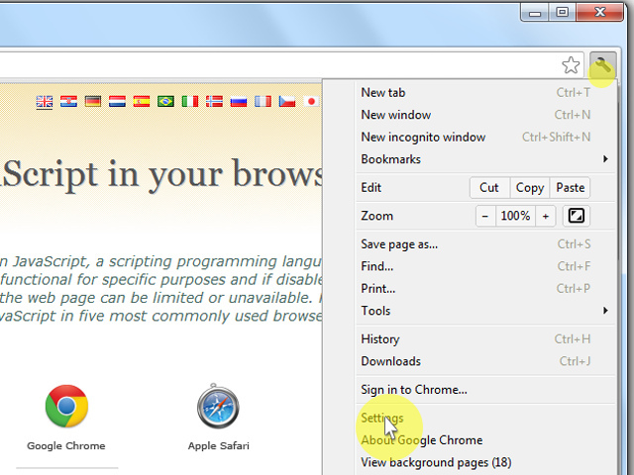
- On the web browser menu click on the "Customize and control Google Chrome" and select "Settings".
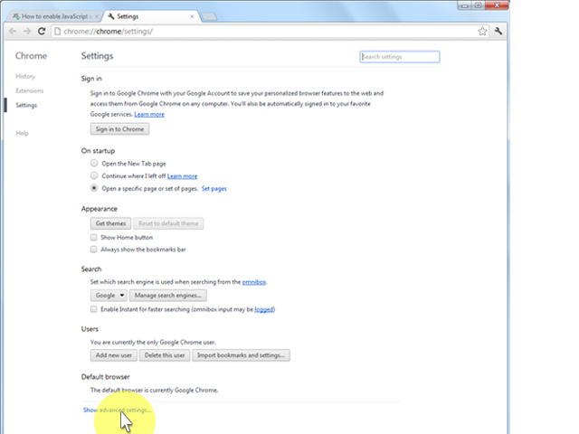
- In the "Settings" section click on the "Show advanced settings..."
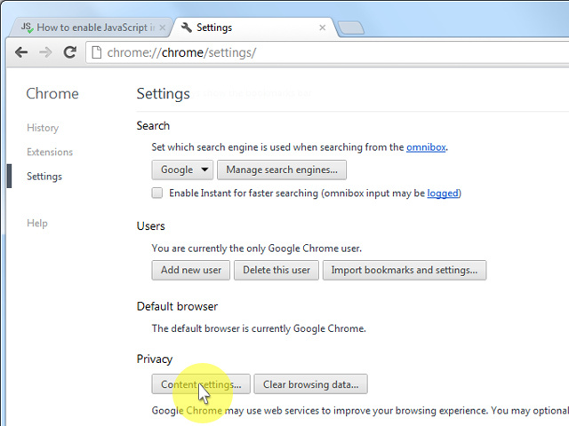
- Under the the "Privacy" click on the "Content settings...".
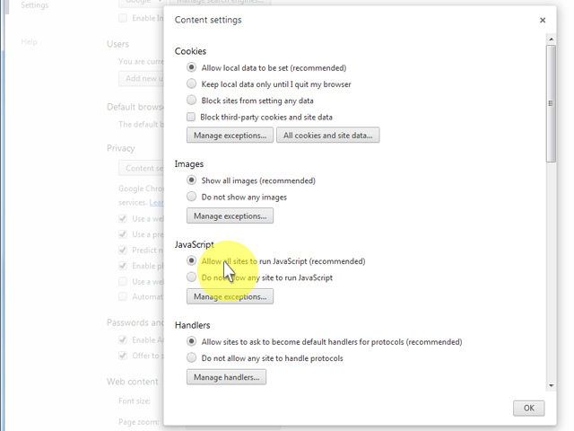
- When the dialog window opens, look for the "JavaScript" section and select "Allow all sites to run JavaScript (recommended)".
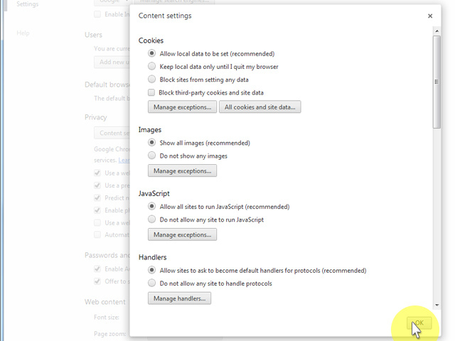
- Click on the "OK" button to close it.
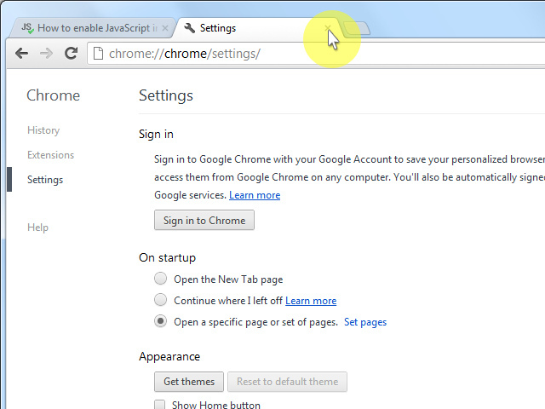
- Close the "Settings" tab.
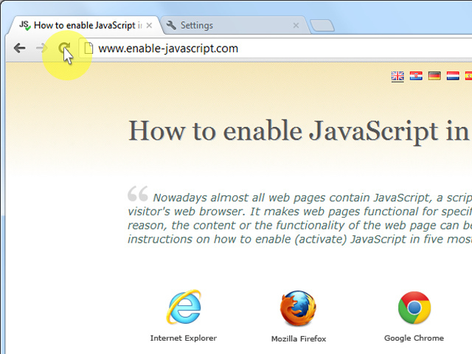
- Click on the "Reload this page" button of the web browser to refresh the page.
___________________________________________________________________

Internet Explorer 9 and above:
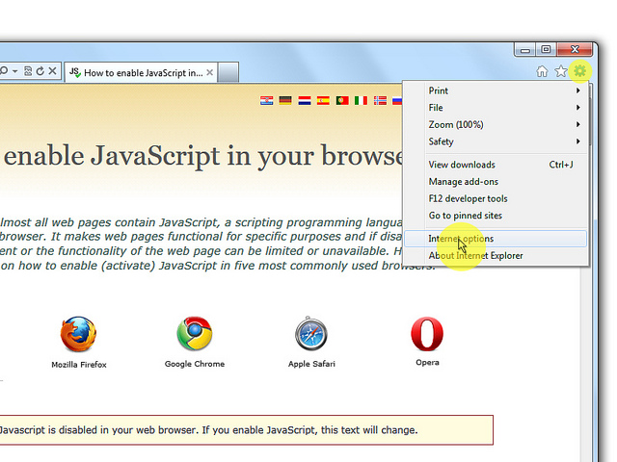
- On web browser menu click "Tools" icon and select "Internet Options".
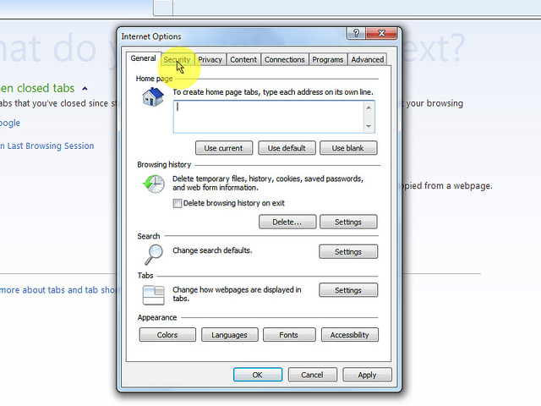
- In the "Internet Options" window select the "Security" tab.
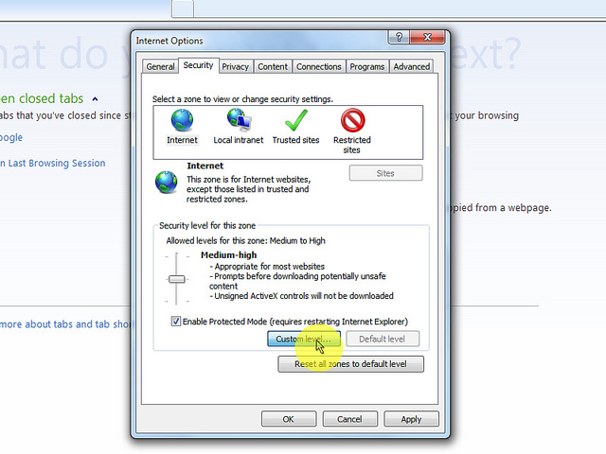
- On the "Security" tab click on the "Custom level..." button.
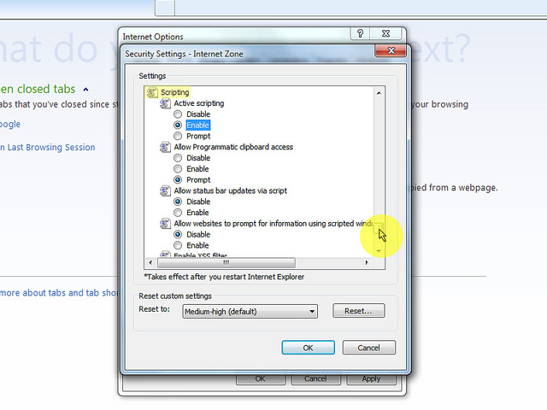
- When the "Security Settings - Internet Zone" dialog window opens, look for the "Scripting" section.
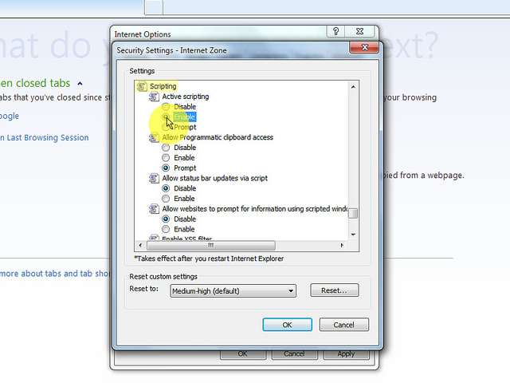
- In the "Active Scripting" item select "Enable".
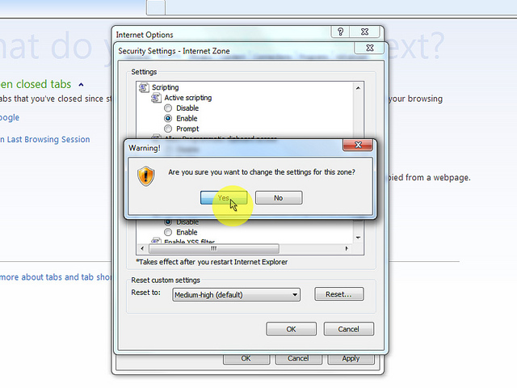
- When the "Warning!" window pops out asking "Are you sure you want to change the settings for this zone?" select "Yes".
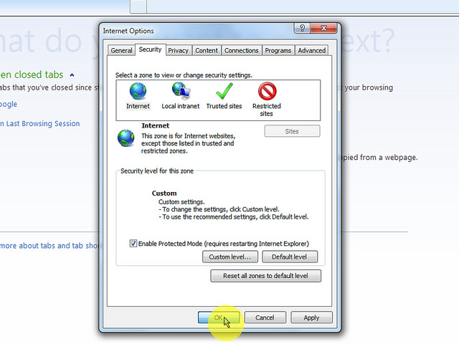
- In the "Internet Options" window click on the "OK" button to close it.
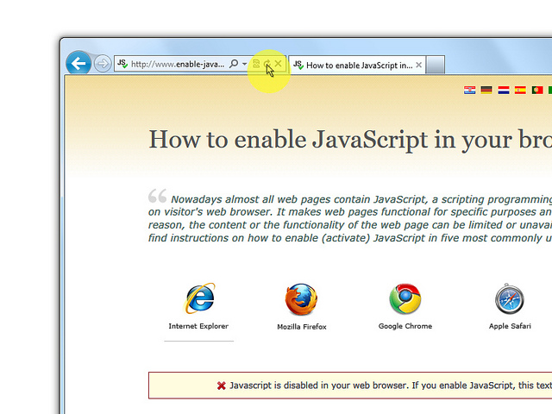
- Click on the "Refresh" button of the web browser to refresh the page.
____________________________________________________________

Internet Explorer 8 and below:
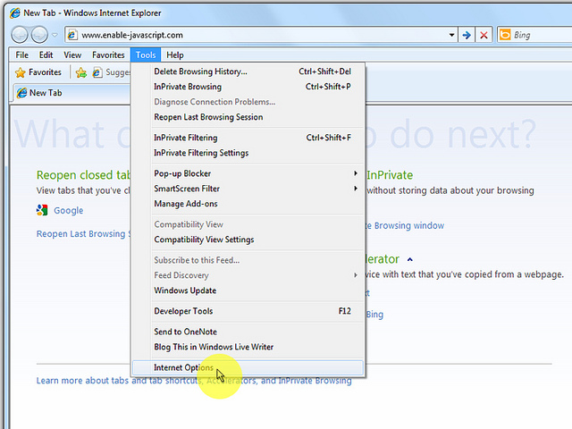
- On web browser menu click "Tools" and select "Internet Options"
- In the "Internet Options" window select the "Security" tab.
- On the "Security" tab click on the "Custom level..." button.
- When the "Security Settings - Internet Zone" dialog window opens, look for the "Scripting" section.
- In the "Active Scripting" item select "Enable".
- When the "Warning!" window pops out asking "Are you sure you want to change the settings for this zone?" select "Yes".
- In the "Internet Options" window click on the "OK" button to close it.
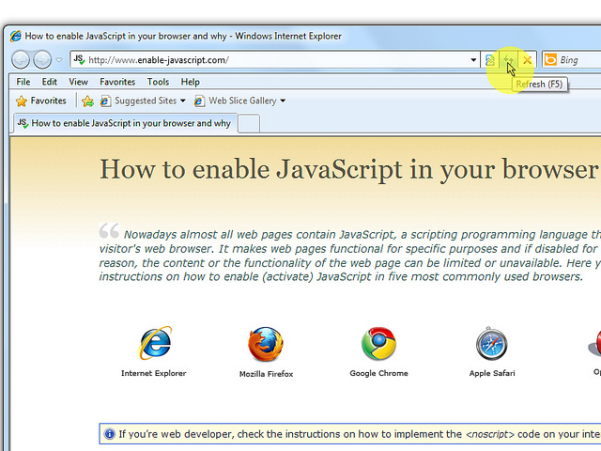
- Click on the "Refresh" button of the web browser to refresh the page.
____________________________________________________________
Mozilla Firefox:
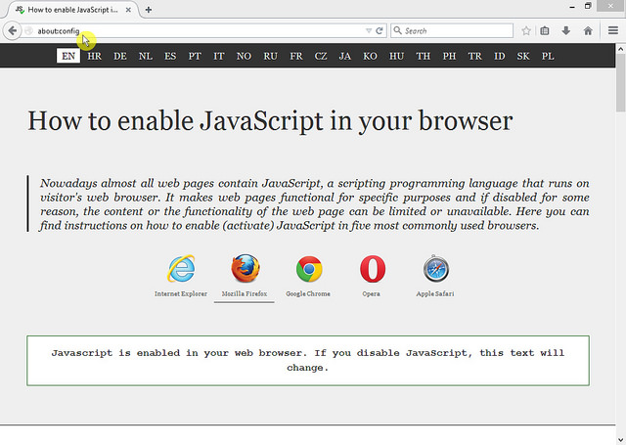
- In the address bar, type about:config and press Enter.
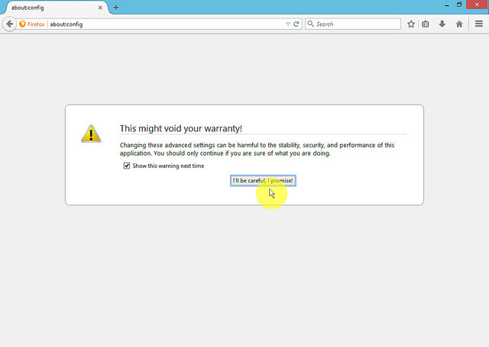
- Click "I'll be careful, I promise" if a warning message appears.
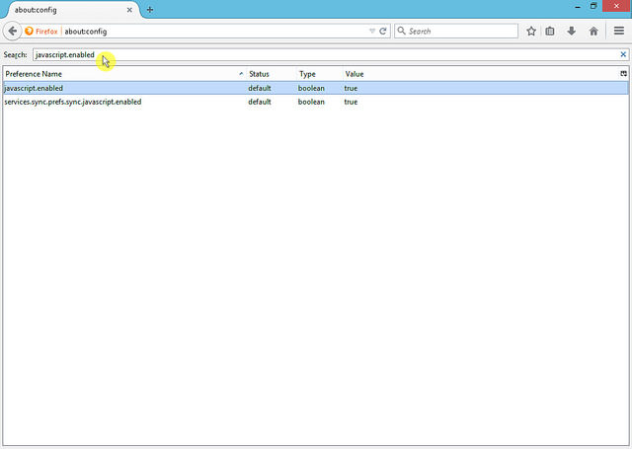
- In the search box, search for javascript.enabled
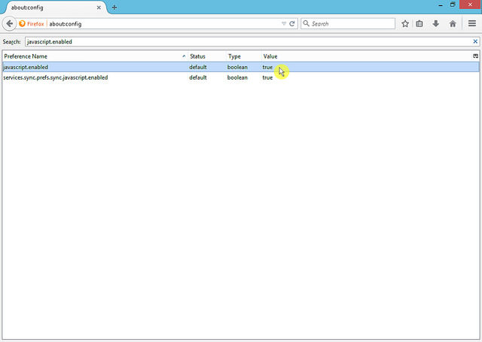
- Toggle the "javascript.enabled" preference (right-click and select "Toggle" or double-click the preference) to change the value from "false" to "true".
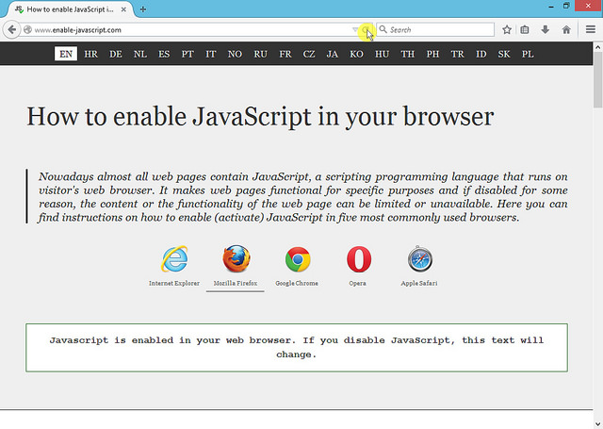
- Click on the "Reload current page" button of the web browser to refresh the page.
____________________________________________________________
Opera:
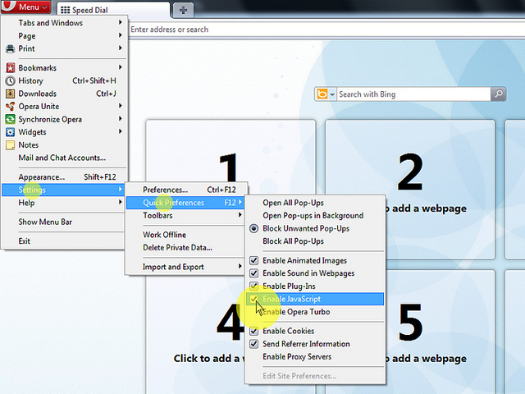
- Click on "Menu", hover mouse on the "Settings" then hover mouse on the "Quick preferences" and mark the "Enable Javascript" checkbox.
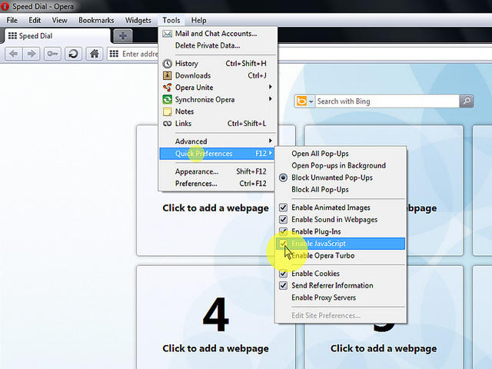
- If "Menu bar" is shown click on the "Tools", hover mouse on the "Quick preferences" and mark the "Enable Javascript" checkbox.
____________________________________________________________
Apple Safari:
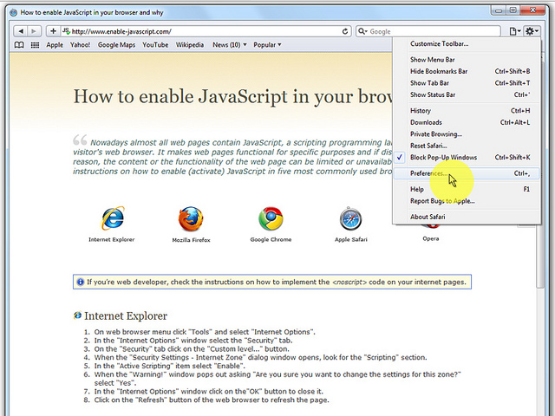
- On the web browser menu click on the "Edit" and select "Preferences".
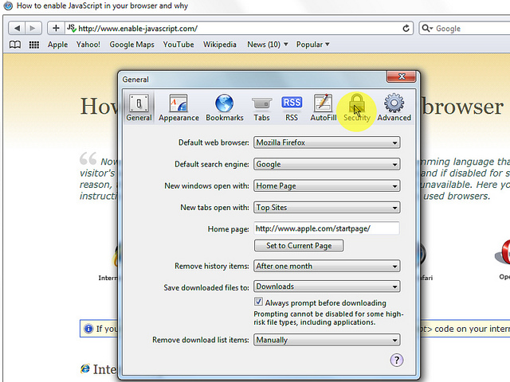
- In the "Preferences" window select the "Security" tab.
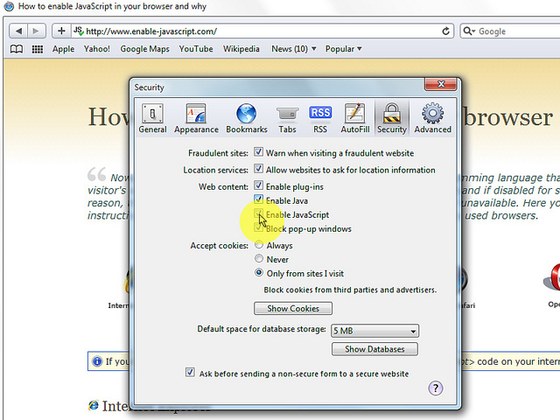
- In the "Security" tab section "Web content" mark the "Enable JavaScript" checkbox.
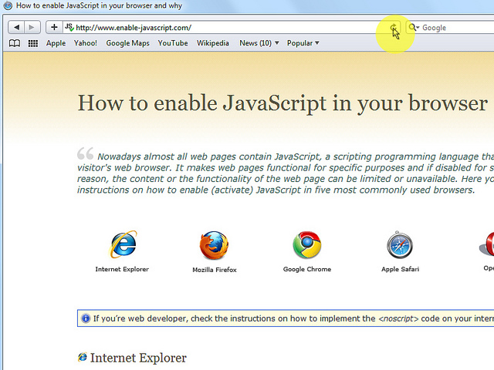
- Click on the "Reload the current page" button of the web browser to refresh the page.

